**MUHAMMAD AHMED RAZA**

--Q-1. Write an SQL query to fetch “FIRST_NAME” from the Worker table using the alias name <WORKER_NAME>.

select FIRST_NAME as WORKER_NAME from worker;

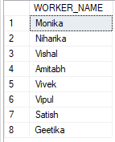

-- Q-2. Write an SQL query to fetch “FIRST_NAME” from the Worker table in upper case.

select upper(FIRST_NAME) from worker;

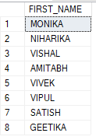

--Q-3. Write an SQL query to fetch unique values of DEPARTMENT from the Worker table.

select distinct DEPARTMENT from worker;

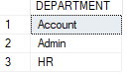

--Q-4. Write an SQL query to print the first three characters of FIRST_NAME from the Worker table.

select substring(FIRST_NAME,1,3) from worker

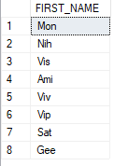

--Q-5. Write an SQL query to find the position of the alphabet (‘a’) in the first name column ‘Amitabh’ from the Worker table.

SELECT CHARINDEX('a', 'Amitabh');  


--Q-6.Write an SQL query to print the FIRST_NAME from the Worker table after removing white spaces from the right side.

select RTRIM(FIRST_NAME) from worker  
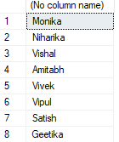

--Q-7. Write an SQL query to print the DEPARTMENT from the Worker table after removing white spaces from the left side.

select LTRIM(DEPARTMENT) from worker

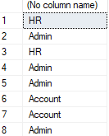

--Q-8. Write an SQL query that fetches the unique values of DEPARTMENT from the Worker table and prints its length.

select distinct(len(DEPARTMENT)) from worker;

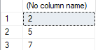

--Q-9. Write an SQL query to print the FIRST_NAME from the Worker table after replacing ‘a’ with ‘A’.

select REPLACE(FIRST_NAME,'a','A') FROM worker

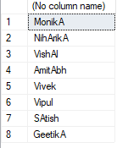

--Q-10. Write an SQL query to print the FIRST_NAME and LAST_NAME from the Worker table into a single column COMPLETE_NAME.

--A space char shouldseparate them.

select concat(FIRST_NAME,' ',LAST_NAME) AS COMPLETE_NAME FROM worker

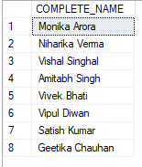

--Q-11. Write an SQL query to print all Worker details from the Worker table order by FIRST_NAME Ascending.

SELECT * FROM WORKER ORDER BY FIRST_NAME ASC

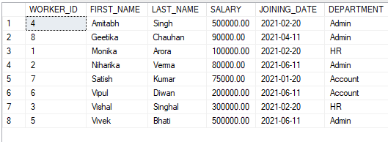

--Q-12. Write an SQL query to print all Worker details from the Worker table order by FIRST_NAME Ascending and DEPARTMENT Descending.

SELECT * FROM WORKER ORDER BY FIRST_NAME ASC ,DEPARTMENT DESC

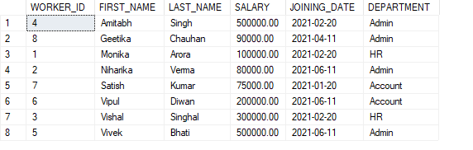

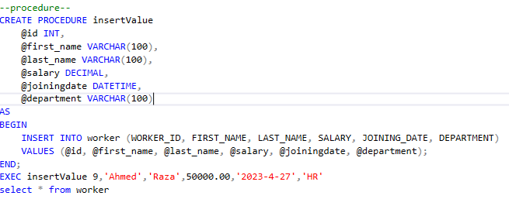

Q-13



select * from worker

Q-14-- veiws--

create view workerVeiws

as

select * from worker

select * from workerVeiws

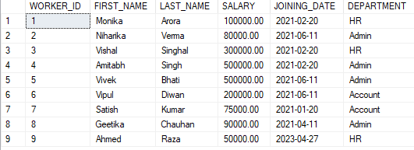

--SELCT WHERE SALARY >100,000

select * FROM workerVeiws WHERE SALARY > 100000

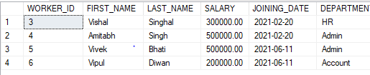

Q-15—triggers

create trigger insertData on WORKER

for insert

as begin

insert into addData

select WORKER_ID,DEPARTMENT from worker

END

INSERT INTO worker values(10,'Micky','Mouse',300000.00,'2021-05-30','Account')

SELECT * FROM addData

